GLOSA React Native App guidance document
Version 1.0
Date: 20.12.2022

Build Environment requirements:
- Mac book with minimum 16 GB RAM
- IPhone for development and testing
- Apple’s developer account
- Xcode
- Visual studio
- Node should be installed

Steps to build the application:
Step 1: Install Node.JS & Watchman on computer.
brew install node
brew install watchman
(Please verify Ruby is installed on the machine, if Yes Cocoapods will be present by default)
Step 2: Install Xcode.
Step 3: Install CLI tools for React Native
npm install -g react-native-cli @react-native-community/cli
Step 4: Building the Project:
- Go the Root Directory of the React Native Project.
npm install
- Go to pubsub-rn/iOS, Install Pod
- pod install
- Go to Root Directory of the project.
- Start React Native Metro:
npx react-native start
- Run the Project
npx react-native run-ios

High level Architecture:
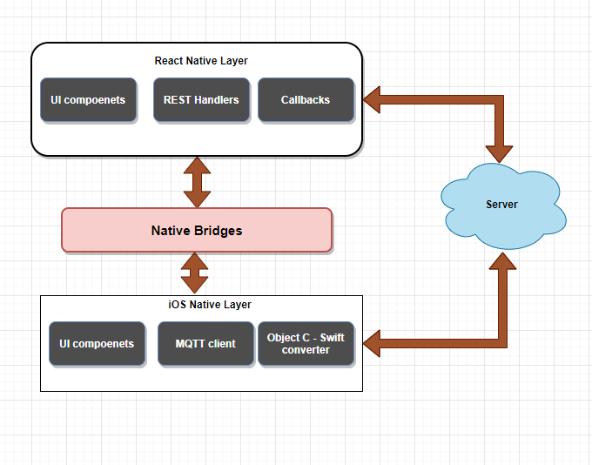
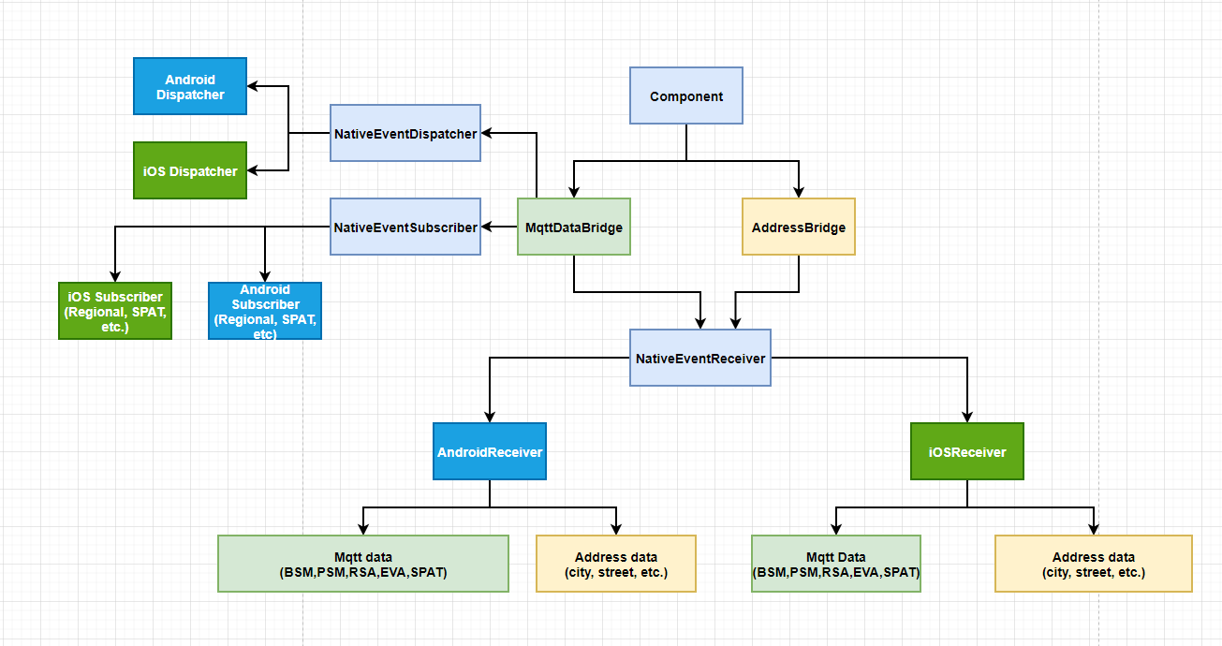
React Native Flow

iOS Flow:
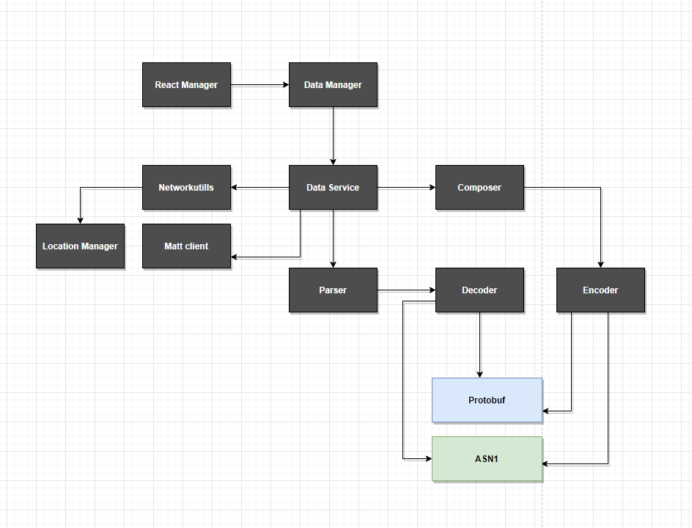

Libraries used
Name | Layer | Purpose | License type
SwiftProtoBuf | iOS | Communication | Apache 2.0
MQTT-Client | iOS | Communication | Eclipse Public
ASN1C | iOS | Communication | Evaluation
react-native-reanimated-carousel | RN | Carousel | Public
react-native-toast-message | RN | Toast | Public
react-native-vector-icons | RN | Vector Icons | Public

Main APIs/ Interfaces:
Name | Language | Purpose
MqttDataBridge | Typescript | This class manage the entire Mqtt data transformation coming from the iOS native layer
AddressDataBridge | Typescript | This the data bridge to manage the address of the device. This will handle the address data coming from the Native layer
NativeEventDispatcher | Typescript | This is the main class to handle all events dispatching to the iOS native layer
NativeEventReceiver | Typescript | This is the main class which will receive the events from the Native layers
NativeEventSubscriber | Typescript | This is the main class to handle all native event subscription for the respective operating systems
IosDispatcher | Typescript | This class will handle the iOS event dispatching to the iOS native layer
IosReceiver | Typescript | This is the main class which will receive all data coming from the iOS native layer
IosSubscriber | Typescript | This class handles the subscribing of the events, and it will communicate to the iOS native bridge
AppUtils | Typescript | This is the Util class which hold all utility methods for the application which will be used in RN layer
EventManager | Swift - iOS | This class is responsible for all kind of communication with RN code.
EventDataManager | Swift - iOS | This is basically iOS layer’s public class. The above RN communication class (EventManager) basically interacts with it.
EventDataService | Swift - iOS | The is Service layer class and responsible for all kind of data flow. The above EventDataManager interacts with it internally for processing all kind of input and output data.
EventNetworkUtil | Swift - iOS | The above Service class (EventDataService) interacts with it to handle all input output requests related to only MQTT. This is responsible basically for all kind of communication with MQTT client iOS lib.
EventDataServiceComposer | Swift - iOS | EventDataService class uses it to format data which need to be send through EventNetworkUtil class. It uses Encoder classes internally which also communicate with Protobuf and ASN1 c to compose data for sending to MQTT server.
EventDataServiceParser | Swift - iOS | EventDataService class uses it to parse data which need to be send to above layer. This data comes from EventNetworkUtil. It uses Decoder classes internally which also communicate with Protobuf and ASN1 c to parse data (which comes from MQTT server) for sending to above layer.
EventLocationManager | Swift - iOS | The above Service class (EventDataService) interacts with it to handle all input output requests related to only GEOCODE. This is responsible to handle all kind of GEOCODE stuffs.

